College of Arts & Sciences

Embry-Riddle Aeronautical University-Worldwide

Peer Observation of Teaching: Policies and Procedures

Context

Peer observation of teaching has become widely accepted as a best practice in institutions that have a demonstrated desire to develop and maintain excellence in instruction. Proponents assert that such observations encourage widespread improvements by creating a sense of community among faculty participating in a process of sharing ideas and advice with colleagues.¹ Feedback on teaching practices also can generate opportunities for a more deliberate and focused professional development plan.

The College of Arts & Sciences (COAS) has clearly established—via both policy and practice—that teaching is central to the mission and vision of the College. An effective peer observation process will support faculty as they strive to facilitate learning in the classroom and promote the attainment of Student Learning Outcomes and General Education Competencies.

Each full-time COAS faculty member will have at least one peer observation of their teaching every academic year. The observation will be included as part of the Annual Performance Evaluation process and, when appropriate, the promotion/tenure portfolio.

Process

The faculty member seeking a peer observation will work with the Department Chair to select the course to be observed, the time frame in which the observation will occur, and the peer who will be asked to do the observation. This information will be included on the Faculty Planning Document.

Observation procedures are as follows:

Pre-observation

The faculty member to be observed:

- Selects the course to be observed
- Provides the observer with any specific areas where they would like to receive feedback (may be written or verbal)

Observation

Observers will:

- Review course playback sessions if the course is an EagleVision course
- Pay attention to specific areas for observation provided by the faculty member
- Examine as necessary all relevant modules that exist in Canvas for the course
- Complete the COAS Peer Observation Form (see below)

Post-observation

The peer observer and the faculty member observed will:

- Debrief from the course observation and review the completed COAS Peer Observation Form
- Discuss strengths and areas for enhancement and improvement, including the observed faculty member’s plans for addressing these items

Upon completion of the post-observation, the observed faculty member will compose a brief reflection statement (no more than one page). The COAS Peer Observation Form and the reflection statement are submitted to the observed faculty member’s Department Chair.

Ratified by COAS INTERIM-DEAN DONNA ROBERTS.
April 29, 2021

¹ Leicester Learning Institute. (n.d.) Peer observation of teaching. Retrieved from ￼https://www2.le.ac.uk/offices/lli/developing-learning-and-teaching/enhance/peer-observation-of-teaching-1
COAS Peer Observation of Teaching Form
Faculty Name: Dr. Darryl Chamberlain Jr.
Observer Name & Title: Brett Werner, Assistant Professor, Department of Mathematics, Science and Technology
Course: DSC 201 - Introduction to Data Science Applications
Course Term: October Term 2025
PRE-OBSERVATION
Context or Background Information and Faculty Focus Requested (to be filled out by faculty member to be observed):
- First time DSCI 201 was taught
- Created new assignments to replace prior low cognitive engagement assignments

POST-OBSERVATION
Observer will:
Discuss strengths and areas for enhancement and improvement (to be written by Peer Observer). This discussion may include items such as engagement with students, quality feedback, and demonstration of subject matter expertise.
- Solid engagement with students; instructor was very active in discussion forums providing new, interesting, and relevant examples related to the course material
- Consistent communication throughout the course with announcements introducing the topics for each week and providing supplemental resources
- Would be good to add a personalized video to your welcome post announcement
FACULTY REFLECTION (1 page)
Glad to see the discussion interactions were noted and appreciated. Students seemed to appreciate my specific comments to their contributions in discussions, such as my responses to the student discussion attempting to classify animals.
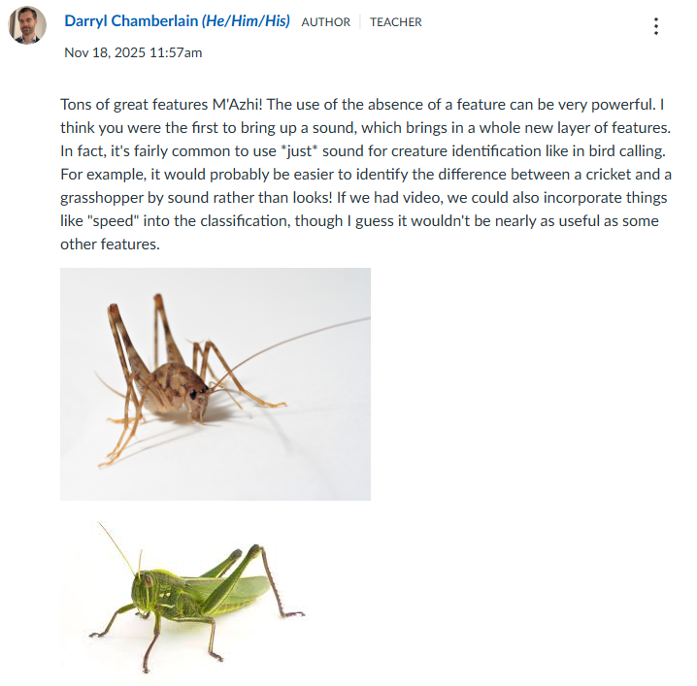

I found providing weekly announcements to be extremely useful to provide additional course resources as the resources available in the shell were insufficient for student learning. I also have received positive student feedback when highlighting student work for the class like below.
